Notes from teacher, adjusting the challenge:
Extended class, no main method
Public class Car
Public car (int theModel, string theMake)
Int getYearModel()
String getMake()
Int getSpeed()
void accelerate()
add 5 to the speed
void brake()
substract 5 from the speed

driver class
public class CarDemo

car name = new Car(__ __)

must add 2 methods
getInputYear() (must be between 1940, 2016)
getIputMake() (checks for empty string)

Java Programming 1
Lab 8

(Download instructions from Blackboard) Creating an external Car class and driver CarDemo class. Alter the instructions for the CarDemo class to include two methods (getInputYear() that returns a year between 1940 and 2016 and getInputMake() that returns the make of the car and checks for an empty String).
- Car.java
- CarDemo.java

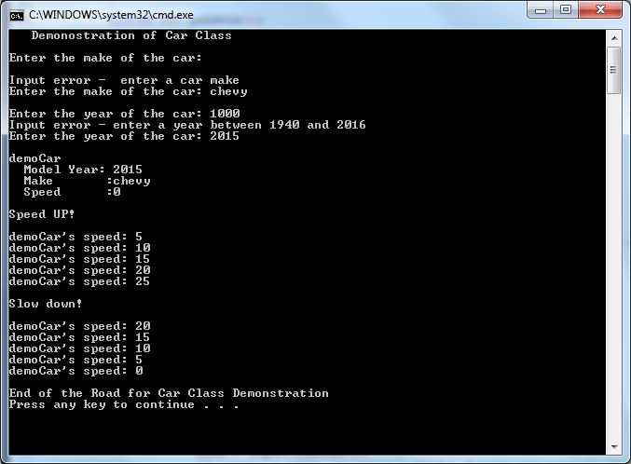

Programming Challenge 2: Car Class

Problem Statement:

Write a class named Car that has the following fields:

- yearModel: The yearModel field is an int that holds the car's year model
- make: The make fiels is a String object that holds the make of the car
- speed: The speed fields is an int that holds the car's current speed
In addition, the class should have the following methods

- Constructor: The constructor should accept the car's year model and make as arguments. These values
should be assigned to the object's yearModel and make fields. The constrictor should also
assign 0 (zero) to the speed field.
- Appropriate accessor methods to get the values stored in an object's yearModel, make, and speed fields.
- accelerate: The accelerate method should add 5 to the speed field each time it is called.
- brake: The brake method should subtract 5 from the speed field each time it is called.

Demonstrate the class in a program that creates a Car object, and then calls the accelerate method five times. After each call to the accelerate method, get the current speed of the car and display it. Then, call the brake method 5 times. After each call to the brake method, get the current speed of the car and display it.

Solution: Car Class

Define What The Car Class Is To Be

Purpose | Model Properties and Behaviors Of a Simple Car
Fields | yearModel  make  speed | the Car's model year  the make of the Car  the car's speed
Constructor |  | Set the values for yearModel and make according to the values provided by the input parameters.  Initialize speed to 0 (zero).
Methods | getYearModel  getMake  getSpeed  accelerator  brake | Return the Car's yearModel  Return the Car's make  Return the Car's speed  Increase the Car's speed by 5  Decrease the Car's speed by 5

High Level Pseudocode for Car Class
1) Define Car Class.
a) Define fields for yearModel, make, and speed.
b) Define the Car Class constructor.
i) Initialize yearModel and make fields with values provided as constructor's parameters.
ii) Initialize speed to 0 (zero).
2) Define Accessor methods
a) Define method getYearModel,
i) Return value of field yearModel.
b) Define method getMake.
i) Return value of field make.
3) Define method getSpeed.
a) Return value of the field speed.
4) Define accelerate method.
a) Increase Car object's speed by 5.
5) Define brake method.
a) Decrease Car object's speed by 5.

Solution: CarDemo Class
Define What The Class Is To Do
Purpose | Demonstrate capabilities of Car class
Input | None
Process | Create an object of type Car. Use the accelerate method 5 times. Use the brake method 5 times.
Output | Display:  - After each use of the accelerator method, display the Car object's speed.  - After each use of the brake method, display the Car object's speed.

High Level Pseudocde for CarDemo Class
1) Create a sample object of type Car.
2) Display the Car object and the value of its fields.
3) Repeat the following activities five times: Notes: USE A FOR LOOP
a) Use the accelerate method to increase the Car object's speed.
b) Display the Car object's current speed.
4) Repeat the following activities five times:
a) Use the brake method to increase the Car object's speed.
b) Display the Car object's current speed.
Note:
A UML diagram is not provided for the CarDemo class; it has no fields and only one method, main.
Detailed Pseudocode for CarDemo Class
1) Create a sample object of type Car.
a) A variable, demoCar, of type Car must be declared.
i) This variable could be named with any legal Java identifier. It is common for objects in Java to have names that include their type, e.g. myCar, anOtherCar, redCar, etc.

b) A new object of type Car must be created. This requires the use of the Car class constructor.
i) The Car class constructor has two parameters: an int specifying demoCar's model year, and a String specifying demoCar's make. Value for these parameters must be provided (they can not be omitted).

Car demoCar = new Car( 2006, "DemoCar Rx");
2) Display the value of demoCar's fields.
a) Use the Car class' accessor methods to retrieve the value of demoCar's fields.
i) To apply a method to an object, write the object's name, a dot '.' and the name of the method including open and close parentheses and any necessary parameters.

demoCar.getYearModel( );
demoCar.getMake( );
demoCar.getSpeed( );

ii) No parameters are required (and are not allowed) on the accessor methods of the Car class. Nevertheless, the open and close parentheses "( )" are required following the method's name.

iii) The values returned by an accessor method can be used in any way that its type can be used in a Java statement. To display the make of object demoCar, write:

System.out.println(" Make :" + demoCar.getMake());

3) Repeat the following activities five times

a) Use the accelerator method to increase the demoCar's speed. This is written:

demoCar.accelerate();

b) Display the demoCar's current speed. This is written:
Systeml.out.println("demoCar's speed: " + demoCar.getSpeed());
4) Repeat the following activities five times

a) Use the brake method to decrease the demoCar's speed. This is written:

demoCar.brake();

b) Display the demoCar's current speed. This is written in the same way it was in the previous step when the demoCar was accelerating.

Program Output
Demonstration of Car Class
demoCar
Model Year: 2006
Make : ExpressoMobile Rx
Speed : 0

Speed Up!
demoCar's speed: 5
demoCar's speed: 10
demoCar's speed: 15
demoCar's speed: 20
demoCar's speed: 25

Slow Down!
demoCar's speed: 20
demoCar's speed: 15
demoCar's speed: 10
demoCar's speed: 5
demoCar's speed: 0

End of the Road for Car Class Demonstration

